Enriched Customer Digital Experience – Factsheet

- HKJC Customer Centre
- Digitize customer service with the direction of more real-time and self-served
- HKJC betting account holders can do the following via HKJC Customer Centre, for examples
  - Maintain personal information and manage password
  - Understand the eligible privileges and register priority services
  - Make bookings of racecourse public betting venues and view booking records
- Available on web browser via desktop, iPad, tablet and mobile phone
- Target launch date: December 2017

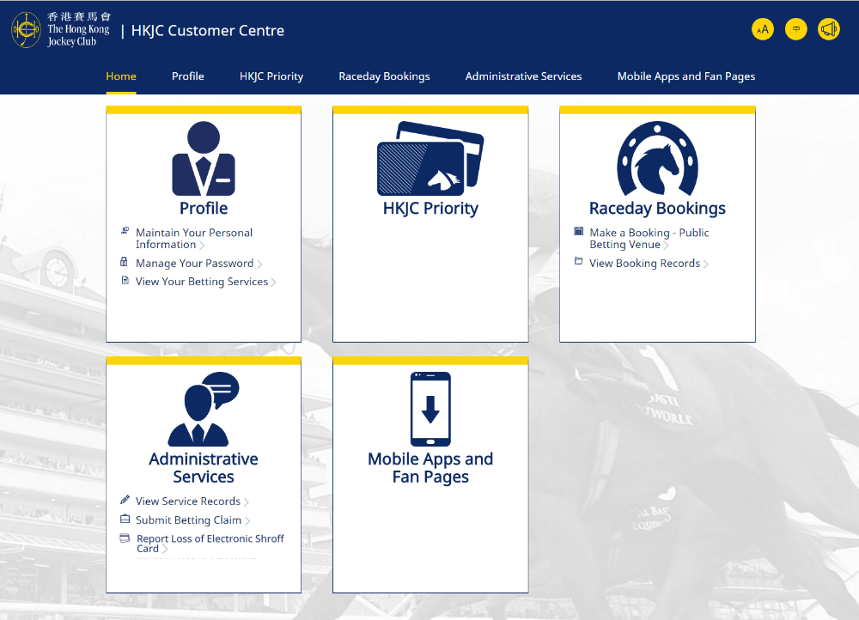
Profile and Password
Management
Eligible Privileges and Services
Table Booking and Records

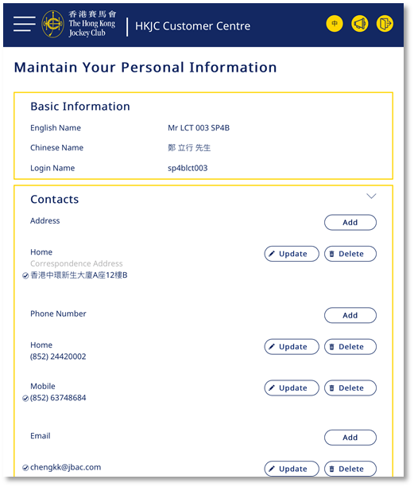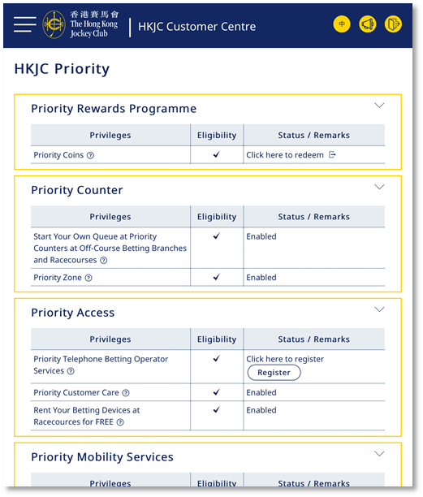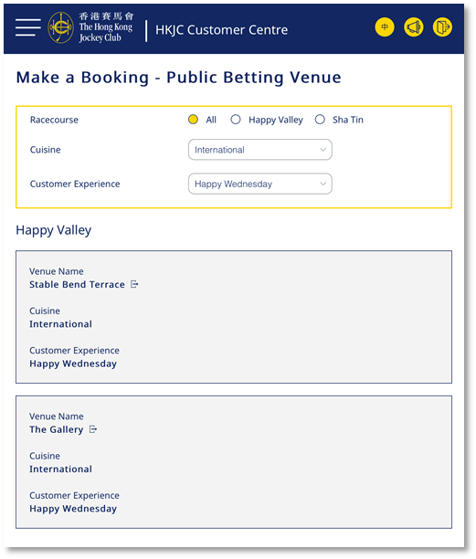
- HKJC TV 2nd Screen of Live Racing

- HKJC TV enhanced with 2nd Screen of Live Racing which enables the racing fans to stay tuned with more instant analysis of races in addition to the racing TV programs.
  - Race Day Statistics: including Draw Statistics, Favourite Horse Performance and Stables’ Results
  - Reminder: First-hand information of a race meeting such as Wind Direction and Track Rolling
  - Forum: Share thoughts and comments among racing fans
- iOS devices (with iOS 7.1 or above) and Android devices (with OS 4.3 or above)
- Target launch date: Start of Season 2017/18

Forum
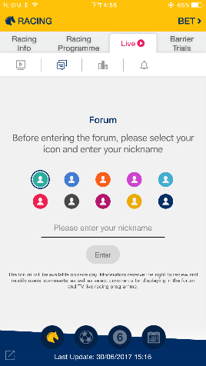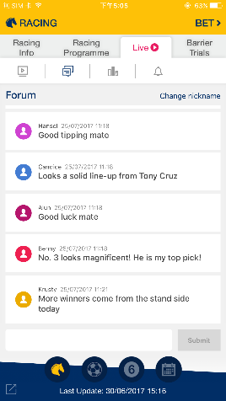

Race Day Statistics
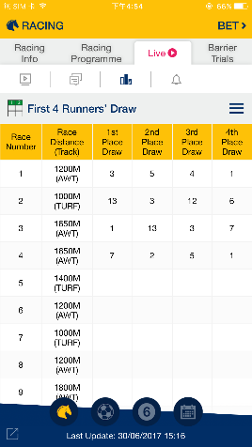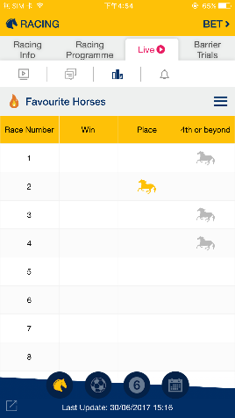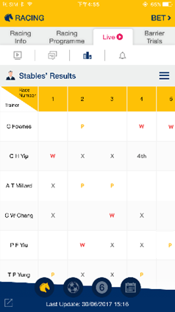
Reminder
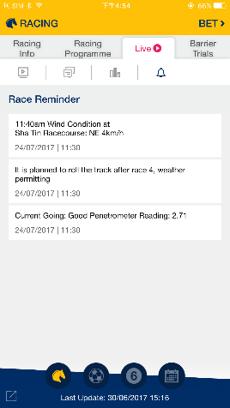

- QR Code Betting – Scan to Bet

- A simple and instant way for customers to place bet with QR code
- Simply scan the specific QR code via HKJC Betting App scanner, the preset betline will be added to betslip directly
- Support betting on Racing, Football and Mark Six
- Available on Classic 3-in-1 Betting App (iOS& AOS) and Racing Touch (iPad & AOS)
- Target launch date: September 2017

Classic 3-in-1 Betting App  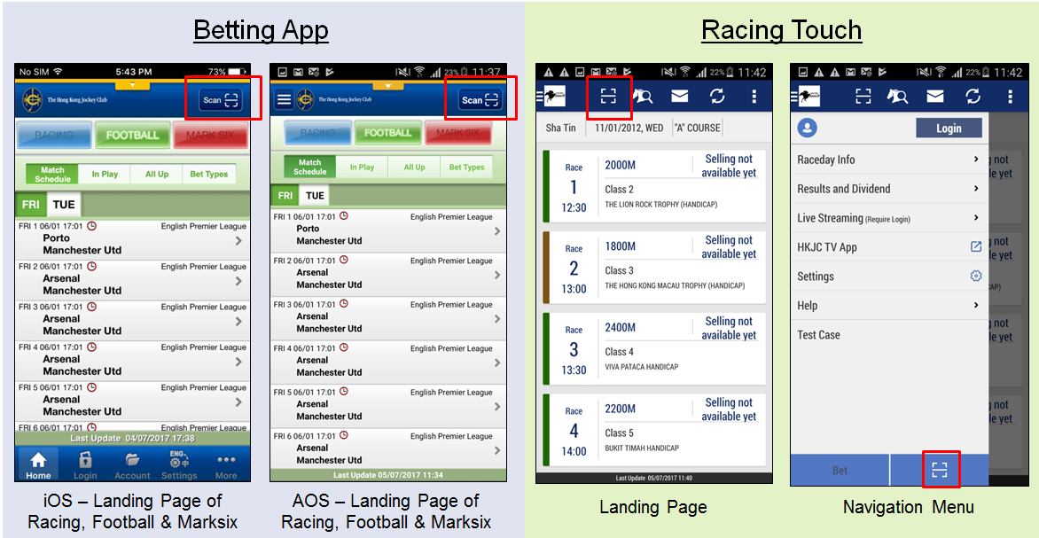 | Racing Touch

- Racecourse Offerings via Alipay HK

There are several Racecourse offerings via Alipay HK App
- Racecourse entrance tickets
  - Alipay HK offers special price at $1
- F&B discount coupons
  - 20% off for the first purchase of $100 F&B coupon
  - Collect 1 E-stamp for each transaction over $100 on HKJC F&B coupon, 5 E-stamps to enjoy the one-off cash rebate of $100
  - For public sit-down venues at Happy Valley and Sha Tin Racecourses, including Hay Market, Digital Zone, Pak Sing, Media Hall, Champion Circle, Jun Hui Ting, adrenaline, Stable Bend, The Gallery, Moon Koon and Leading Edge
  - Limited quota
- First period for promotion will be from end of September 2017 with limited quota and surprising offers in future

HKJC Racecourse on Alipay HK  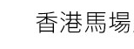  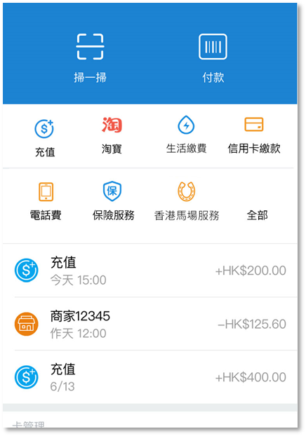 | Entrance Tickets and  F&B Coupons  

