Spotlight

Mr Stunning has peaked for the last two editions of this race and will attempt to become the Hong Kong Sprint’s first three-time winner. But he faces the flash new kid on the Hong Kong sprinting block, Aethero, who will attempt to become the first Southern Hemisphere-bred three-year-old to win a G1 at the HKIR: the chestnut, sensational when winning the recent G2 Jockey Club Sprint (1200m), has drawn comparisons to past champion Able Friend. The outstanding line-up includes plenty of other top-class contenders too: the talented grey Hot King Prawn is back from a setback and is a G2 winner of untapped potential at this level, while Hong Kong’s champion sprinter Beat The Clock is in, as is D B Pin, runner-up in the past two editions.

Japan’s Danon Smash and Australia’s In Her Time provide the overseas challenge. The former is a three-time G3 winner who has posted smart efforts in Japan’s two G1 sprints this year, placing fourth in the Takamatsunomiya Kinen (1200m) and third in the Sprinters Stakes (1200m). In Her Time has won the G1 Galaxy and G1 Black Caviar Lightning and was a fine third in the G1 VRC Sprint Classic (1200m) last time.

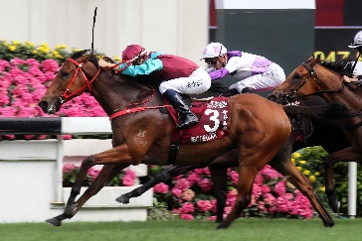 | BEAT THE CLOCK  HONG KONG 6g 120  Hong Kong champion sprinter with G1 wins in Chairman’s Sprint Prize and Centenary Sprint Cup and never out of first three in 22 career starts. | 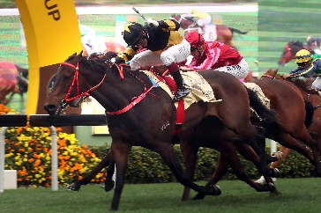 | D B PIN  HONG KONG 7g 119  G1 winner at the course and distance and runner-up in the last two editions of this race, returned from injury with a fine sixth in G2 Jockey Club Sprint latest.
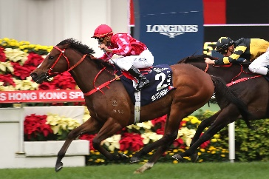 | MR STUNNING  HONG KONG 7g 119  Shooting for a hat-trick after winning the last two editions of this race and returned from a stress fracture to finish a fair eighth in G2 Jockey Club Sprint latest. | 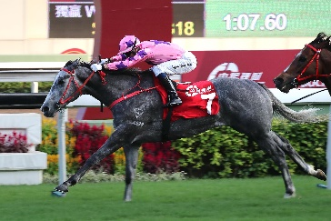 | HOT KING PRAWN  HONG KONG 5g 118  Hong Kong’s rising star sprinter this time last year but ninth as favourite in this race; unraced rest of season after colic surgery but returned to run second in recent G2 Jockey Club Sprint.
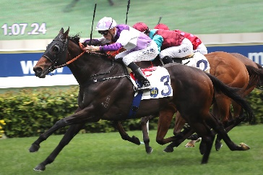 | RATTAN  HONG KONG 6g 117  Mile/seven-furlong winner who switched to sprinting last term and won a 1200m G2 before placing second in the G1 Chairman’s Sprint Prize at the track and trip. | 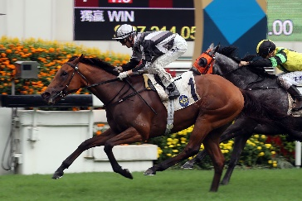 | LITTLE GIANT  HONG KONG 7g 116  Career best fourth in this race last year and ended campaign with success in a G3 handicap at the course and distance.
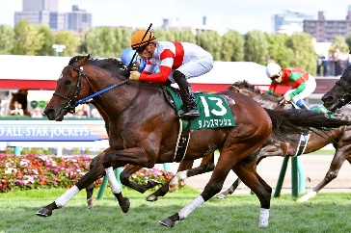 | DANON SMASH  JAPAN 4c 114  Multiple G3 winner and thereabouts in Japan’s G1 sprints this season including third in the Sprinters Stakes. | 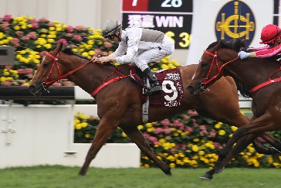 | IVICTORY  HONG KONG 6g 114  Hong Kong’s champion sprinter two seasons ago, springing off a Class 2 win at Happy Valley to win the G1 Chairman’s Sprint Prize but below that form since.
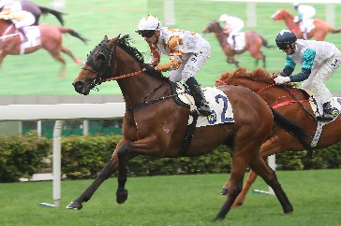 | WISHFUL THINKER  HONG KONG 6g 113  Smart sprinter with six wins from 20 starts and always thereabouts in Pattern races; only previous G1 attempt resulted in seventh in the Al Quoz Sprint at Meydan. | 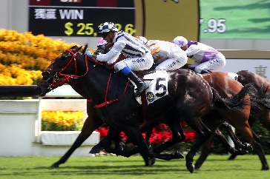 | SEASONS BLOOM  HONG KONG 7g 112  A leading miler and won G1 Stewards’ Cup in 2018 before form dipped; revitalised at 1200m this term and won G2 Premier Bowl Handicap last time.
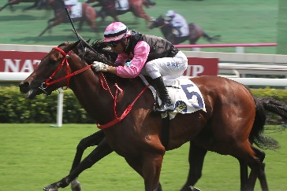 | FULL OF BEAUTY  HONG KONG 5g 106  Won first five career starts last term and has since added a G3 handicap win at 1000m, closed to fourth from a wide draw in recent G2 Jockey Club Sprint. | 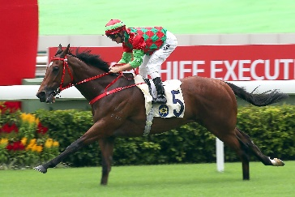 | REGENCY LEGEND  HONG KONG 4g 104  Won first four starts - all at 1200m - including impressive first-up score this term in Class 1 but disappointed when down the field in G2 Jockey Club Sprint latest.
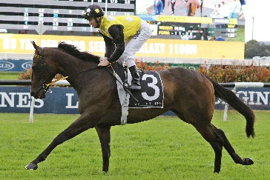 | IN HER TIME  AUSTRALIA 7m 115  Won the 2018 G1 Galaxy and 2019 Black Caviar Lightning and posted another top-class effort when third in the G1 VRC Sprint Classic last time. | 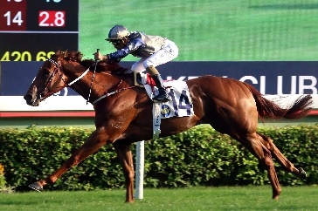 | AETHERO  HONG KONG 3g 119  Unbeaten all three starts as a 2yo last term, lowered Sacred Kingdom’s 1000m Sha Tin track record this season and beat the best in G2 Jockey Club Sprint.

